Names:

**Question 1 (6 pnts)**

a. Network scheme of a brushed DC-motor.

b. Equation back EMF:

$$E=k_{e}*ω$$

Equation motor torque:

$$T_{m}=k_{t}*I_{a}$$

c. Calculation of armature resistance.

$$R_{a}=\frac{V_{in}}{I_{stall}} at 0=ω R_{a}=\frac{12}{7}=1.71Ω$$

d. Calculation of torque constant.

$$-R_{a}*I_{a}+U_{t}=E_{a} -1.71*1.5+12=9.44$$

$$ω=\frac{2pi*\left(204+43.8\right)}{60}=937.7\frac{rad}{s} k_{t}=\frac{9.44}{935.7}=0.01\frac{Nm}{A}$$

e. Calculation of efficiency

$$T_{atMotor}=0.01\frac{Nm}{A}*1.68A=0.0168Nm$$

$$ω_{atMotor}=\left(200rpm*\frac{2π}{60}\right)*43.8=917.3\frac{rad}{s}$$

$$P_{in}=917.3\frac{rad}{s}*0.0168Nm=15.41W$$

$$P_{out}=\left(200rpm*\frac{2π}{60}\right)*0.35Nm$$

$$Efficiency=\frac{P_{out}}{P_{in}}=47.6\%$$

f. Relationship between the shaft speed in [rpm] and the encoder frequency in [Hz].

$$\frac{f*60}{PPR}=n[rpm]$$

**Question 3 (6 pnts)**

a. Graph of CS+ at a duty-cycle of 66.7% and 50kHz switching frequency (Vin = 12V).

Student couples:

 Martin Marinov 2124573

Henryk Nowacki 2128013

b. Relation between average voltage on CS+ as a function of the duty-cycle at a 12V battery voltage.

$$V_{cs}=12V*duty cycle$$

c. Graphs of currents through the 4 mosfets at a 3 [A] load current (duty-cycle = 66.7%, fswitch =50kHz).

d. Selected mosfet:PMV20ENR

Link to datasheet:

Maximum drain-source voltage =30V Continuous drain current at 25°C = 7.6A

RDSON =21mΩ Threshold voltage (typical)= 2V

trise = 17ns tfall = 8ns

Unit price = 0.068 Dollars

e. Calculation of power losses and efficiency at: duty-cycle= 66.7%, fswitch =50kHz, Vin=12V and Iload = 3A.

$$P_{out}=V*I*d=12*3*0.667=24.012W$$

$$P_{in}={(R}_{dson}*I^{2}*d)+0.5*V*I*f*(t_{rise}+t_{fall})$$

$P_{in1}=(12*{10}^{-3}*3^{2}*0.667)+0.5*12*3*50000*(17*{10}^{-9}+8*{10}^{-9}$) = 0.0945W

$P_{in2}=\left(12*{10}^{-3}*3^{2}*0.333\right)+0.5*12*3*50000*\left(17*{10}^{-9}+8*{10}^{-9}\right)=0.0585W$

$$P_{in3}=\left(12*{10}^{-3}*3^{2}\right)=0.108W$$

$Efficiency=\frac{P_{out}}{P_{out}+ΔP}=\frac{24.012W}{24.012W+0.0945W+0.0585W+0.108W}$ =98.9%

f. Purpose of C13 and C15:

They provide additional voltage to the upper mosfet

Connection of VS, C13 and C15:

VS must be connected to the **source of the high-side MOSFET (Q1/Q3)** and the **drain of the low-side MOSFET (Q2/Q4)**.

**Right-hand pin of C15** goes to **VS** (the switch node between Q3 and Q4).

**Right-hand pin of C13** is tied to **VS** (the switch node between Q1 and Q2).

**Question 4 (3 pnts)**

a. Relationship output voltage current sensor INA181A1IDBVT as a function of the voltages on IN+, IN- and REF.

$$V_{out}=\left({V_{in}}_{+}-{V_{in}}_{-}\right)*20\frac{V}{V} +V_{ref}$$

b. Calculation of R1 and R38 in order to get VCS = 0.3V at -3A and VCS=-3.0V at +3A.

$$V_{ref}=\frac{3+0.3}{2}=1.65V I_{R37}=\frac{1.65}{10000}=1.65*{10}^{-4} A$$

$$V_{cs}=I*R_{shunt}*gain+V_{ref} R_{series}=\frac{3.3}{1.65*{10}^{-4}}=20kΩ$$

$$0.3=-3*R_{1}*20+1.65 R_{1}=22.5mΩ R_{38}=20k-10k=10kΩ$$

c. Calculation of C11 to get an attenuation of 100 at 50kHz.

$$\left|H\left(f\right)\right|=\frac{1}{sqrt\left(1+{\left(2pifRC\right)}^{2}\right)}=\frac{1}{\left|H\right|}=100 at f=50kHz \\ 2pifRC=sqrt\left({100}^{2}-1\right)=100=>RC=\frac{100}{2pi*50000}=3.18*{10}^{-4} s \\ C11=\frac{RC}{R24}=\frac{3.18*{10}^{-4}}{330}=9.65*{10}^{-7}F=0.97µF$$

**Question 5 (4 pnts)**

a. Calculation of R44

$$Vs=\frac{V_{in}}{5}=V_{in}*\frac{R_{23}}{R_{44}+R_{23}}=>\frac{1}{5}=\frac{10k}{R_{44}+10k}=R_{44}=40kΩ$$

b. Calculation of cutoff- frequency input filter.

$$f_{in}=\frac{1}{2pi*R_{th}*C_{16}}=\frac{1}{2pi*8000*330*{10}^{-9}}=60.3Hz$$

$$R_{th}=\frac{40k}{50k}=8kΩ$$

Calculation of cutoff- frequency output filter

$$f_{out}=\frac{1}{2pi*R_{22}*C_{18}}=\frac{1}{24*330*330*{10}^{-9}}=1.46kHz$$

c. Calculation of accuracy.

$$\frac{R_{23}}{R_{44}+R_{23}}=k$$

$$k=\frac{10k ohms}{39k ohms+10k ohms}=0.20408$$

$$k_\min{=\frac{9.9}{9.9+39.39}=0.201}$$

$$k_\max{=\frac{10.1}{10.1+38.61}0.2073}$$

$$V_{var}=2.412→2.4876$$

$$Error=3.15\%$$

**The input bias current error is very small around 0.15µV therefore the difference is negligible**

**Question 6 (2 pnts)**

a. Calculation of R32 to obtain a 5V supply voltage.

$$V_{in}=5V V_{2}=0.75 V_{1}=4.25 R_{1}=10330$$

$$I=\frac{4.25}{10330}=0.411mA R_{32}=\frac{0.75}{0.411}=1825Ω$$

b. Calculation power losses and temperature rise of the LMR14050S at a 12V input voltage and a 0.2A load current.

Efficiency = 90%

$$P_{in}=\frac{5*0.2}{0.9}=1.111 W$$

$$P_{loss}=P_{in}-P_{out}=0.111 W$$

$$Delta T=42.5*0.111=4.72\deg{celcius}$$

**Question 7 (1 pnt)**

Explanation what a pull-up resistor is.

Used to pull up the data line from 0v (0) to 3.3V(1)

Typical value of I2C pullup resistor:

4.7kΩ

**Question 8 (2 pnt)**

a. Calculation of the total current consumption of the RGB LED if all 3 leds are turned on.

$$I=\frac{V_{in}-V_{f}}{R} V_{in}=3.3V { I}_{1}=\frac{3.3-1.9}{220}=6.4mA I_{2}=\frac{3.5-2.5}{220}=3.6mA I_{3}=\frac{3.5-2.5}{220}=3.6mA$$

b. Calculation of buzzer current at 3.3V.

$I=\frac{3.3}{43}=77mA$

Maximum current of a GPIO pin of the ESP32

20mA=max

**Question 9 (2 pnts)**

Fill in the last 3 columns of the table below

|  |  |  |  |  |
| --- | --- | --- | --- | --- |
| Signal | Description of signal | GPIO-pin ESP32 | Connector | Pin |
| 5.0V | Plus of 5V power supply (connected via diode, see figure 2.6) | - | J1_ESP32 | 1 |
| 3.3V | Plus of 3.3V power supply | - | J2_ESP32 | 1 |
| Ground | Power supply (minus) | - | J1_ESP32 | 2 |
| Ground | Power supply (minus) | - | J2_ESP32 | 2 |
| RX2 | Receive pin serial port connection ESP32 with high level controller | GPIO16 | J2_ESP32 | 6 |
| TX2 | Transmit pin serial port connection ESP32 with high level controller | - | J2 | 7 |
| SCL | I2C clock signal (communication bus with module IMU MPU6050) | GPIO22 | J2 | 14 |
| SDA | I2C data signal (communication bus with module IMU MPU6050) | GPIO21 | J2 | 11 |
| enc_A | Encoder output A | GPIO27 | J1 | 6 |
| enc_B | Encoder output B | GPIO14 | J1 | 5 |
| pwm1 | PWM signal of half bridge 1 | GPIO25 | J1 | 8 |
| pwm2 | PWM signal of half bridge 2 | GPIO26 | J1 | 7 |
| enable | Enable signal of both half bridges | GPIO5 | J2 | 8 |
| CS | Analogue output voltage of current sensor | GPIO13 | J1 | 3 |
| VS | Analogue output voltage of voltage sensor | GPIO12 | J1 | 4 |
| button1 | Push button 1 | GPIO32 | J1 | 10 |
| button2 | Push button 2 | GPIO33 | J1 | 9 |
| button3 | Push button 3 | GPIO34 | J1 | 12 |
| green | Green LED of RGB LED | GPIO15 | J2 | 3 |
| red | Red LED of RGB LED | GPIO2 | J2 | 4 |
| blue | Blue LED of RGB LED | GPIO4 | J2 | 5 |
| buzzer | Signal that controls a buzzer | GPIO19 | J2 | 10 |

**Question 10 (1 pnts)**

What is a decoupling capacitor?

A decoupling capacitor's job is to supress high-frequency noise in power supply signals. They take tiny voltage ripples, which could otherwise be harmful to delicate ICs, out of the voltage supply.

List all decoupling capacitors used in the hardware design of the motor controller.

C1, C2, C3, C4, C5, C6, C7, C8, C9, C10, C12, C14, C16, C17, C20, C21, C25.

**Question 11 (20 pnts)**

Screen dump of PCB-design.

*Remark: A folder with the easyEDA project, the BOM, Ferber files and the Pick and Place file must also be turned in.*

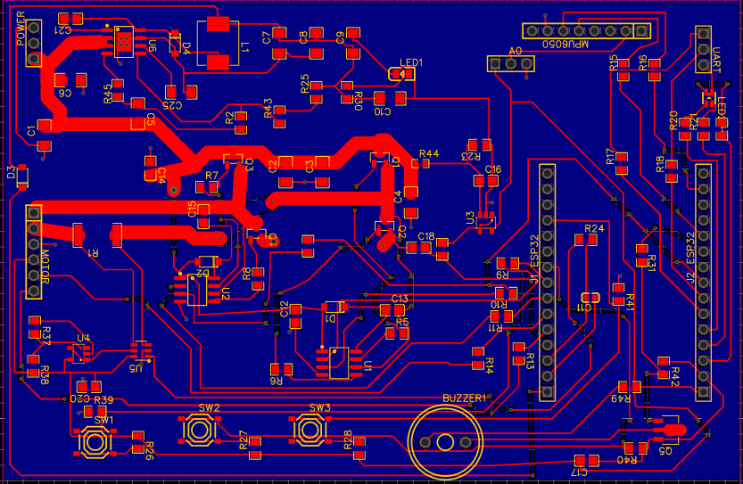

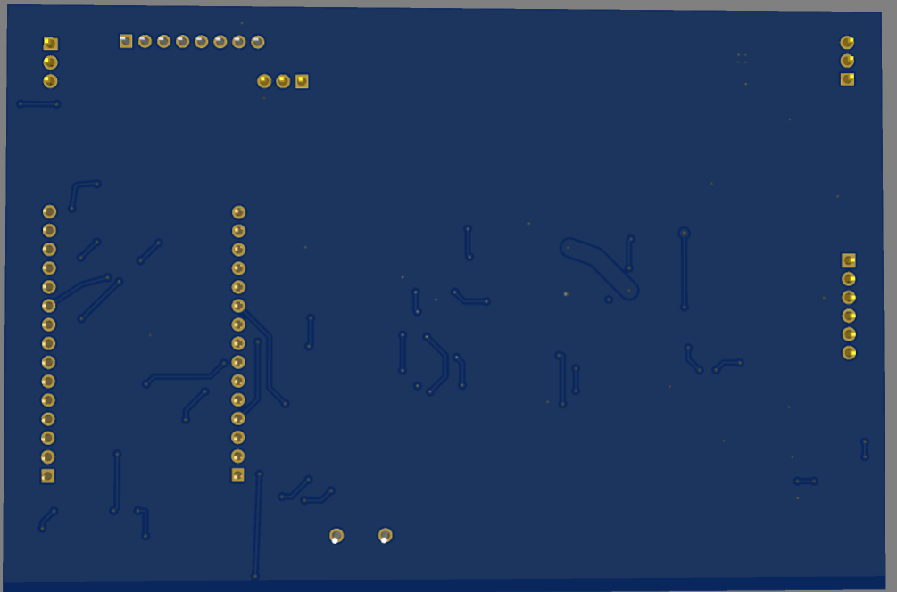

**Question 12 (2 pnts)**

Picture(s) of PCB with resistors R1, R32, R38 and R44 soldered.

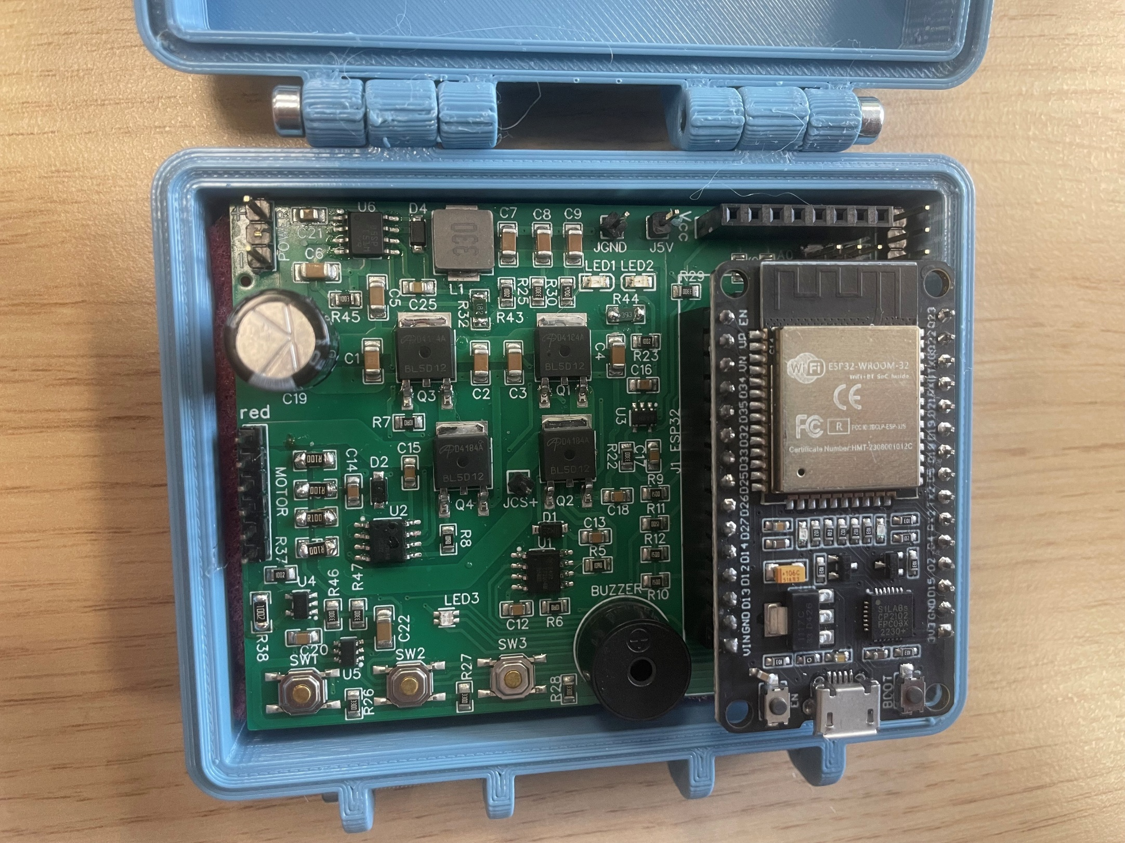

**Question 13 (4 pnt)**

a. Fill in the table below.

|  |  |  |  |  |  |  |  |  |  |  |
| --- | --- | --- | --- | --- | --- | --- | --- | --- | --- | --- |
| Supply voltage [V] (unloaded) | 5.86 | 6.86 | 7.86 | 8.86 | 9.86 | 10.86 | 11.86 | 12.86 | 13.86 | 14.86 |
| Voltage on J5V [V] (unloaded) | 5.03 | 5.03 | 5.03 | 5.03 | 5.03 | 5.03 | 5.03 | 5.03 | 5.03 | 5.03 |
| Supply current [mA] (unloaded) | 95 | 83 | 74 | 67 | 60 | 55 | 52 | 48 | 45 | 43 |
| Supply voltage [V] (loaded) | 5.86 | 6.86 | 7.86 | 8.86 | 9.86 | 10.86 | 11.86 | 12.86 | 13.86 | 14.86 |
| Voltage on J5V [V] (loaded) | 4.976 | 4.978 | 4.979 | 4.978 | 4.982 | 4.98 | 4.978 | 4.979 | 4.99 | 4.982 |
| Supply current [mA] (loaded) | 540 | 467 | 412 | 369 | 334 | 305 | 280 | 260 | 244 | 228 |

b. Plot of voltage and efficiency of the 5V-supply as a function of the input voltage at a 10

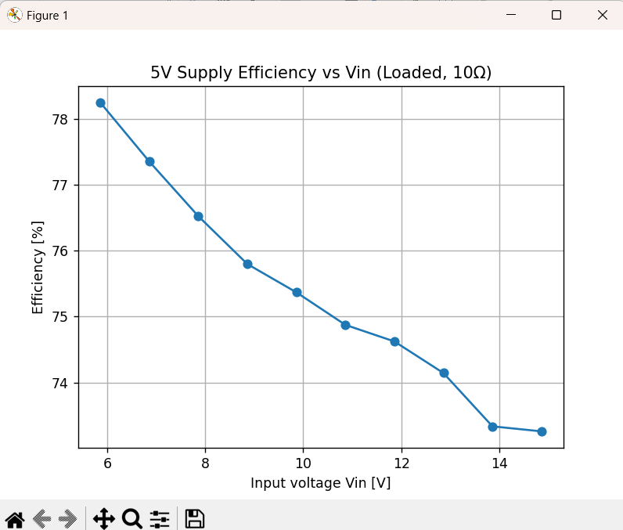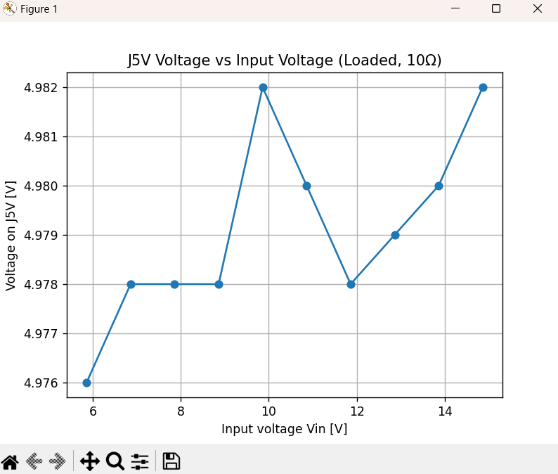

Python script to make the plots. *Remark: The python script file must also be turned in a folder named Q13.*

import matplotlib.pyplot as plt  
  
# Data from the photo — LOADED situation  
vin = [5.86, 6.86, 7.86, 8.86, 9.86, 10.86, 11.86, 12.86, 13.86, 14.86] # Input voltage [V]  
vj5 = [4.976, 4.978, 4.978, 4.978, 4.982, 4.98, 4.978, 4.979, 4.98, 4.982] # J5V voltage [V]  
iin_mA = [540, 467, 412, 369, 334, 305, 280, 260, 244, 228] # Supply current (loaded) [mA] — from photo  
  
# --- Efficiency ---  
  
iin = [x/1000 for x in iin_mA] # A  
iout = [v/10.0 for v in vj5] # A, from 10Ω load  
efficiency = [(v*io)/(vi*ii) if (vi*ii)!=0 else 0.0 for v, io, vi, ii in zip(vj5, iout, vin, iin)]  
  
# Plot J5V voltage vs input voltage  
plt.figure()  
plt.plot(vin, vj5, marker='o')  
plt.xlabel('Input voltage Vin [V]')  
plt.ylabel('Voltage on J5V [V]')  
plt.title('J5V Voltage vs Input Voltage (Loaded, 10Ω)')  
plt.grid(True)  
plt.show()  
  
# Plot Efficiency vs input voltage  
plt.figure()  
plt.plot(vin, [e*100 for e in efficiency], marker='o')  
plt.xlabel('Input voltage Vin [V]')  
plt.ylabel('Efficiency [%]')  
plt.title('5V Supply Efficiency vs Vin (Loaded, 10Ω)')  
plt.grid(True)  
plt.show()

**Question 14 (4 pnts)**

Python script files boot.py and main.py to test the user interface.

*Remark: Both python script files must also be submitted in a folder named Q14.*

Contents of boot.py:

# boot.py — run once at boot, before main.py

import micropython

# Allow clear error messages if something goes wrong inside IRQs

micropython.alloc_emergency_exception_buf(100)

print("boot.py: system ready")

Contents of main.py:

# main.py — ESP32 MicroPython (Thonny)

from machine import Pin, PWM, Timer

import micropython

import utime

# ---------------- Pin map (from assignment) ----------------

LED_R_PIN = 19 # Red

LED_G_PIN = 5 # Green

LED_B_PIN = 18 # Blue

SW1_PIN = 39 # Button 1 -> Red (GPIO36/39 are input-only, no internal pulls)

SW2_PIN = 36 # Button 2 -> Green

SW3_PIN = 15 # Button 3 -> Blue (has internal pull-up if needed)

BUZZER_PIN = 4

# ---------------- Configuration ----------------

INVERT_OUTPUT = False # set True if LEDs are inverted on your PCB

DEBOUNCE_MS = 120

SIREN_FREQS = (375, 500)

SIREN_PERIOD_MS = 400 # ms

# ---------------- Safety for IRQs ----------------

micropython.alloc_emergency_exception_buf(100)

# ---------------- LED helpers ----------------

_led_r = Pin(LED_R_PIN, Pin.OUT)

_led_g = Pin(LED_G_PIN, Pin.OUT)

_led_b = Pin(LED_B_PIN, Pin.OUT)

def _led_write(pin_obj, on):

# If outputs are inverted (e.g., common-anode), flip the level

pin_obj.value(1 if (on ^ INVERT_OUTPUT) else 0)

def _led_read(pin_obj):

raw = pin_obj.value()

return (raw == 1) ^ INVERT_OUTPUT

# start with LEDs OFF

_led_write(_led_r, False)

_led_write(_led_g, False)

_led_write(_led_b, False)

# ---------------- Buzzer (PWM) ----------------

_buzzer_pwm = PWM(Pin(BUZZER_PIN))

_buzzer_pwm.freq(SIREN_FREQS[0])

def _buzzer_on():

# duty compatibility: some ports have duty(), others duty_u16()

try:

_buzzer_pwm.duty(512) # 0..1023 on ESP32 classic

except AttributeError:

_buzzer_pwm.duty_u16(32768) # 0..65535

def _buzzer_off():

try:

_buzzer_pwm.duty(0)

except AttributeError:

_buzzer_pwm.duty_u16(0)

_buzzer_off()

_siren_timer = Timer(0)

_siren_idx = 0

_siren_active = False

def _siren_timer_cb(t):

global _siren_idx

_siren_idx ^= 1

_buzzer_pwm.freq(SIREN_FREQS[_siren_idx])

def _siren_start():

global _siren_active, _siren_idx

if _siren_active:

return

_siren_idx = 0

_buzzer_pwm.freq(SIREN_FREQS[_siren_idx])

_buzzer_on()

_siren_timer.init(period=SIREN_PERIOD_MS, mode=Timer.PERIODIC, callback=_siren_timer_cb)

_siren_active = True

def _siren_stop():

global _siren_active

if not _siren_active:

return

_siren_timer.deinit()

_buzzer_off()

_siren_active = False

def _recompute_siren():

if _led_read(_led_r) and _led_read(_led_g) and _led_read(_led_b):

_siren_start()

else:

_siren_stop()

def _toggle_led_and_update(led_pin_obj):

_led_write(led_pin_obj, not _led_read(led_pin_obj))

_recompute_siren()

# ---------------- Buttons (interrupt + debounce) ----------------

# Expect the PCB to provide pulls for 36/39. We enable pull-up on 15.

_sw1 = Pin(SW1_PIN, Pin.IN)

_sw2 = Pin(SW2_PIN, Pin.IN)

_sw3 = Pin(SW3_PIN, Pin.IN, Pin.PULL_UP)

_last_sw1_ms = 0

_last_sw2_ms = 0

_last_sw3_ms = 0

def _pressed(pin_obj):

# Treat "pressed" as LOW (active-low typical). If your PCB is active-high, change to == 1.

return pin_obj.value() == 0

# scheduler targets (avoid lambda allocations in IRQ)

def _sched_toggle_r(_):

_toggle_led_and_update(_led_r)

def _sched_toggle_g(_):

_toggle_led_and_update(_led_g)

def _sched_toggle_b(_):

_toggle_led_and_update(_led_b)

def _irq_sw1(pin):

global _last_sw1_ms

now = utime.ticks_ms()

if utime.ticks_diff(now, _last_sw1_ms) < DEBOUNCE_MS:

return

_last_sw1_ms = now

if _pressed(_sw1):

micropython.schedule(_sched_toggle_r, 0)

def _irq_sw2(pin):

global _last_sw2_ms

now = utime.ticks_ms()

if utime.ticks_diff(now, _last_sw2_ms) < DEBOUNCE_MS:

return

_last_sw2_ms = now

if _pressed(_sw2):

micropython.schedule(_sched_toggle_g, 0)

def _irq_sw3(pin):

global _last_sw3_ms

now = utime.ticks_ms()

if utime.ticks_diff(now, _last_sw3_ms) < DEBOUNCE_MS:

return

_last_sw3_ms = now

if _pressed(_sw3):

micropython.schedule(_sched_toggle_b, 0)

EDGE = Pin.IRQ_FALLING | Pin.IRQ_RISING

_sw1.irq(trigger=EDGE, handler=_irq_sw1)

_sw2.irq(trigger=EDGE, handler=_irq_sw2)

_sw3.irq(trigger=EDGE, handler=_irq_sw3)

print("main.py: running — press SW1/SW2/SW3 to toggle R/G/B; all ON => siren")

# keep alive; work happens in IRQs

while True:

utime.sleep_ms(250)

**Question 15 (4 pnts)**

a. Fill in the table below (measurement of VS as a function of Vin).

|  |  |  |  |  |  |  |  |  |  |  |
| --- | --- | --- | --- | --- | --- | --- | --- | --- | --- | --- |
| Vin [V]  (multimeter) | 6 | 7 | 8 | 9 | 10 | 11 | 12 | 13 | 14 | 15 |
| VS [mV]  (ESP32) | 1240 | 1450 | 1660 | 1862 | 2068 | 2278 | 2485 | 2676 | 2880 | 3083 |

b. Graph of VS as a function of Vin.

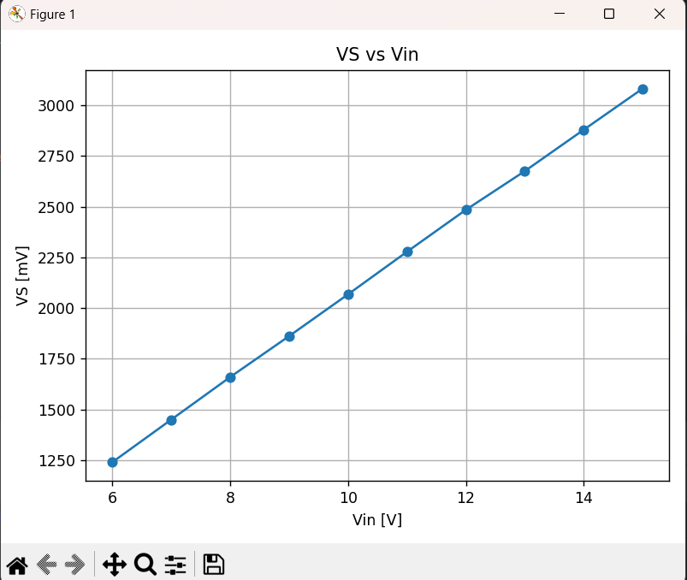

c. Average proportional factor of Vin/VS determined from measurements. c1 = 4.839695

Average proportional factor of Vin/VS determined from R23 and R44. c1 = 4.9

Difference between both values in percentage = 1.23%

Given an explanation if the difference is more than 3%.

Python script to make the plot of question b and to calculate the average ratio of Vin / VS

*Remark: This file must also be submitted in a folder named Q15.py*

# q15_plot_and_ratio.py  
# Requirements: numpy, matplotlib  
  
import numpy as np  
import matplotlib.pyplot as plt  
  
# ---- measurements (from the table) ----  
Vin_V = np.array([6, 7, 8, 9, 10, 11, 12, 13, 14, 15], dtype=float)  
VS_mV = np.array([1240, 1450, 1660, 1862, 2068, 2278, 2485, 2676, 2880, 3083], dtype=float)  
  
# ---- (b) Plot VS vs Vin ----  
plt.figure()  
plt.plot(Vin_V, VS_mV, marker='o')  
plt.xlabel('Vin [V]')  
plt.ylabel('VS [mV]')  
plt.title('VS vs Vin')  
plt.grid(True)  
plt.tight_layout()  
plt.show()  
  
# ---- (c) Compute c1 from measurements and from theory ----  
VS_V = VS_mV / 1000.0  
  
# Average proportional factor (measured): mean(Vin / VS)  
c1_meas = np.mean(Vin_V / VS_V)  
  
# Theoretical c1 from divider:  
# VS = Vin * R_bottom / (R_top + R_bottom)  
# => Vin/VS = (R_top + R_bottom) / R_bottom  
# Use the orientation that matches your board: top=39k, bottom=10k  
R_top = 39_000.0 # ohms (R23 physically at Vin side)  
R_bottom = 10_000.0 # ohms (R44 to GND)  
c1_theory = (R_top + R_bottom) / R_bottom  
  
# Percent difference  
diff_pct = 100.0 * (c1_meas - c1_theory) / c1_theory  
  
print(f"Measured c1 (mean Vin/VS): {c1_meas:.6f}")  
print(f"Theoretical c1 from R_top={R_top/1000:.0f}k, R_bottom={R_bottom/1000:.0f}k: {c1_theory:.6f}")  
print(f"Difference (meas - theory) / theory: {diff_pct:+.2f}%")

**Question 16 (4 pnts)**

a. Fill in the tables below (Measurement of VCS as a function of positive and negative current )

|  |  |  |  |  |  |  |  |  |  |
| --- | --- | --- | --- | --- | --- | --- | --- | --- | --- |
| I [A]  (multimeter) | 0 | 0.3 | 0.6 | 0.9 | 1.2 | 1.5 | 1.8 | 2.06 |  |
| VCS [V]  (ESP32) | 1.672 | 1.8 | 1.93 | 2.06 | 2.19 | 2.32 | 2.45 | 2.55 |  |

|  |  |  |  |  |  |  |  |  |  |
| --- | --- | --- | --- | --- | --- | --- | --- | --- | --- |
| I [A]  (multimeter) | 0 | 0.3 | 0.6 | 0.9 | 1.2 | 1.5 | 1.8 | 2.06 |  |
| VCS [V]  (ESP32) | 1.672 | 1.544 | 1.417 | 1.283 | 1.153 | 1.024 | 0.89 | 0.78 |  |

b. Plot of VCS as a function of the curre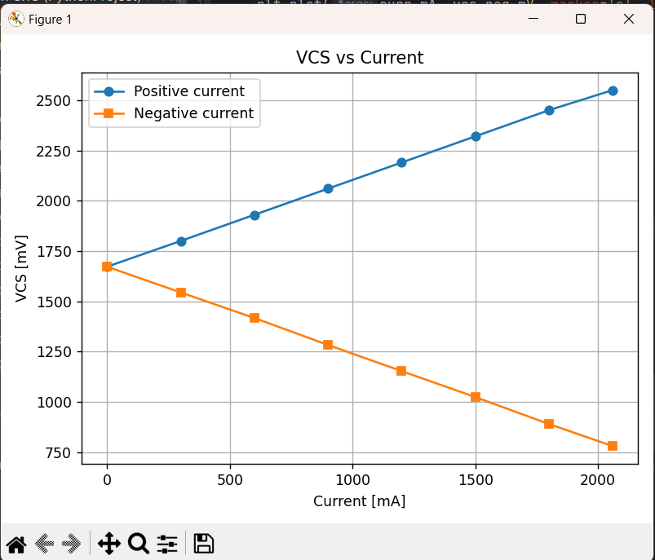nt.

c. Values of I0 and c2 found via linear regression:

I0 = -3.8736 A c2 = 2.3182 A/V

Theoretical values of I0 and c2 based on values of R1 and R38:

I0 = -3.3 A c2 = 2 A/V

Difference between both values of I0 in percentage = 15.91%

Difference between both values of c2 in percentage = 17.38%

Given an explanation if the difference is more than 3%.

*Remark: The python script must also be submitted in a folder named Q16.py*

import numpy as np  
import matplotlib.pyplot as plt  
  
# -----------------------------  
# Measured data from 16b  
# -----------------------------  
# Current sweep [A] and VCS [V] for +I  
I_pos = np.array([0, 0.3, 0.6, 0.9, 1.2, 1.5, 1.8, 2.06])  
V_pos = np.array([1.672, 1.8, 1.93, 2.06, 2.19, 2.32, 2.45, 2.55])  
  
# Current sweep [A] and VCS [V] for –I (currents negated)  
I_neg = -np.array([0, 0.3, 0.6, 0.9, 1.2, 1.5, 1.8, 2.06])  
V_neg = np.array([1.672, 1.544, 1.417, 1.283, 1.153, 1.024, 0.89, 0.78])  
  
# Combine both polarities  
V = np.concatenate([V_pos, V_neg]) # VCS [V]  
I = np.concatenate([I_pos, I_neg]) # Current [A]  
  
# -----------------------------  
# Linear regression: I = I0 + c2 * VCS  
# -----------------------------  
c2, I0 = np.polyfit(V, I, 1) # slope, intercept  
  
# -----------------------------  
# Theoretical expectations  
# -----------------------------  
# INA181A1 gain and shunt; 3.3 V rail with 10k:10k divider -> Vref = ~1.65 V  
G = 20.0 # INA181A1 gain (change if your variant differs)  
R1 = 25e-3 # 25 mΩ shunt  
Vcc = 3.3 # ESP32/board supply  
R_top = 10e3 # divider top resistor (e.g., R37)  
R_bottom = 10e3 # divider bottom resistor (R38 = 10 kΩ)  
Vref = Vcc * (R_bottom / (R_top + R_bottom))  
  
c2_th = 1.0 / (G * R1) # A/V  
I0_th = -Vref / (G * R1) # A  
  
# Percentage differences  
def pct(meas, th):  
 return 100.0 * (meas - th) / th  
  
c2_diff_pct = pct(c2, c2_th)  
I0_diff_pct = pct(I0, I0_th)  
  
# -----------------------------  
# Print results  
# -----------------------------  
print(f"Fitted model: I = I0 + c2*VCS")  
print(f" I0 (fit) = {I0:.4f} A")  
print(f" c2 (fit) = {c2:.4f} A/V")  
print()  
print(f"Theory (G={G:.0f}, R1={R1*1e3:.1f} mΩ, Vref={Vref:.3f} V):")  
print(f" I0_th = {I0_th:.4f} A")  
print(f" c2_th = {c2_th:.4f} A/V")  
print()  
print(f"Percent difference:")  
print(f" ΔI0 = {c2_diff_pct:.2f}%")  
print(f" Δc2 = {I0_diff_pct:.2f}%")  
  
# -----------------------------  
# Plot in requested units (mA vs mV)  
# -----------------------------  
plt.figure()  
plt.scatter(V*1000, I*1000, marker='x', label='Measured points')  
V_line = np.linspace(V.min()-0.1, V.max()+0.1, 200)  
I_fit = I0 + c2 * V_line  
plt.plot(V_line*1000, I_fit*1000, label='Linear fit')  
  
plt.xlabel('VCS [mV]')  
plt.ylabel('Current [mA]')  
plt.title('I = I0 + c2·VCS (linear regression)')  
plt.grid(True)  
plt.legend()  
plt.tight_layout()  
plt.show()

**Question 17 (3 pnt)**

a. Fill in the table below

|  |  |  |  |
| --- | --- | --- | --- |
|  | Frequency scope- voltage [kHz] | Duty-cycle bridge [%] | Make scope image |
| pwm1 = 300, pwm2 = 0 | 50 | 29.3 | Yes |
| pwm1 = 600, pwm2 = 0 | 50 | 58.5 | No |
| pwm1 = 900, pwm2 = 0 | 50 | 87.8 | No |
| pwm1 = 0, pwm2 = 300 | 50 | 29.3 | No |
| pwm1 = 0, pwm2 = 600 | 50 | 58.5 | Yes |
| pwm1 = 0, pwm2 = 900 | 50 | 87.8 | No |

Scope-image at pwm1 = 300, pwm2 = 0.

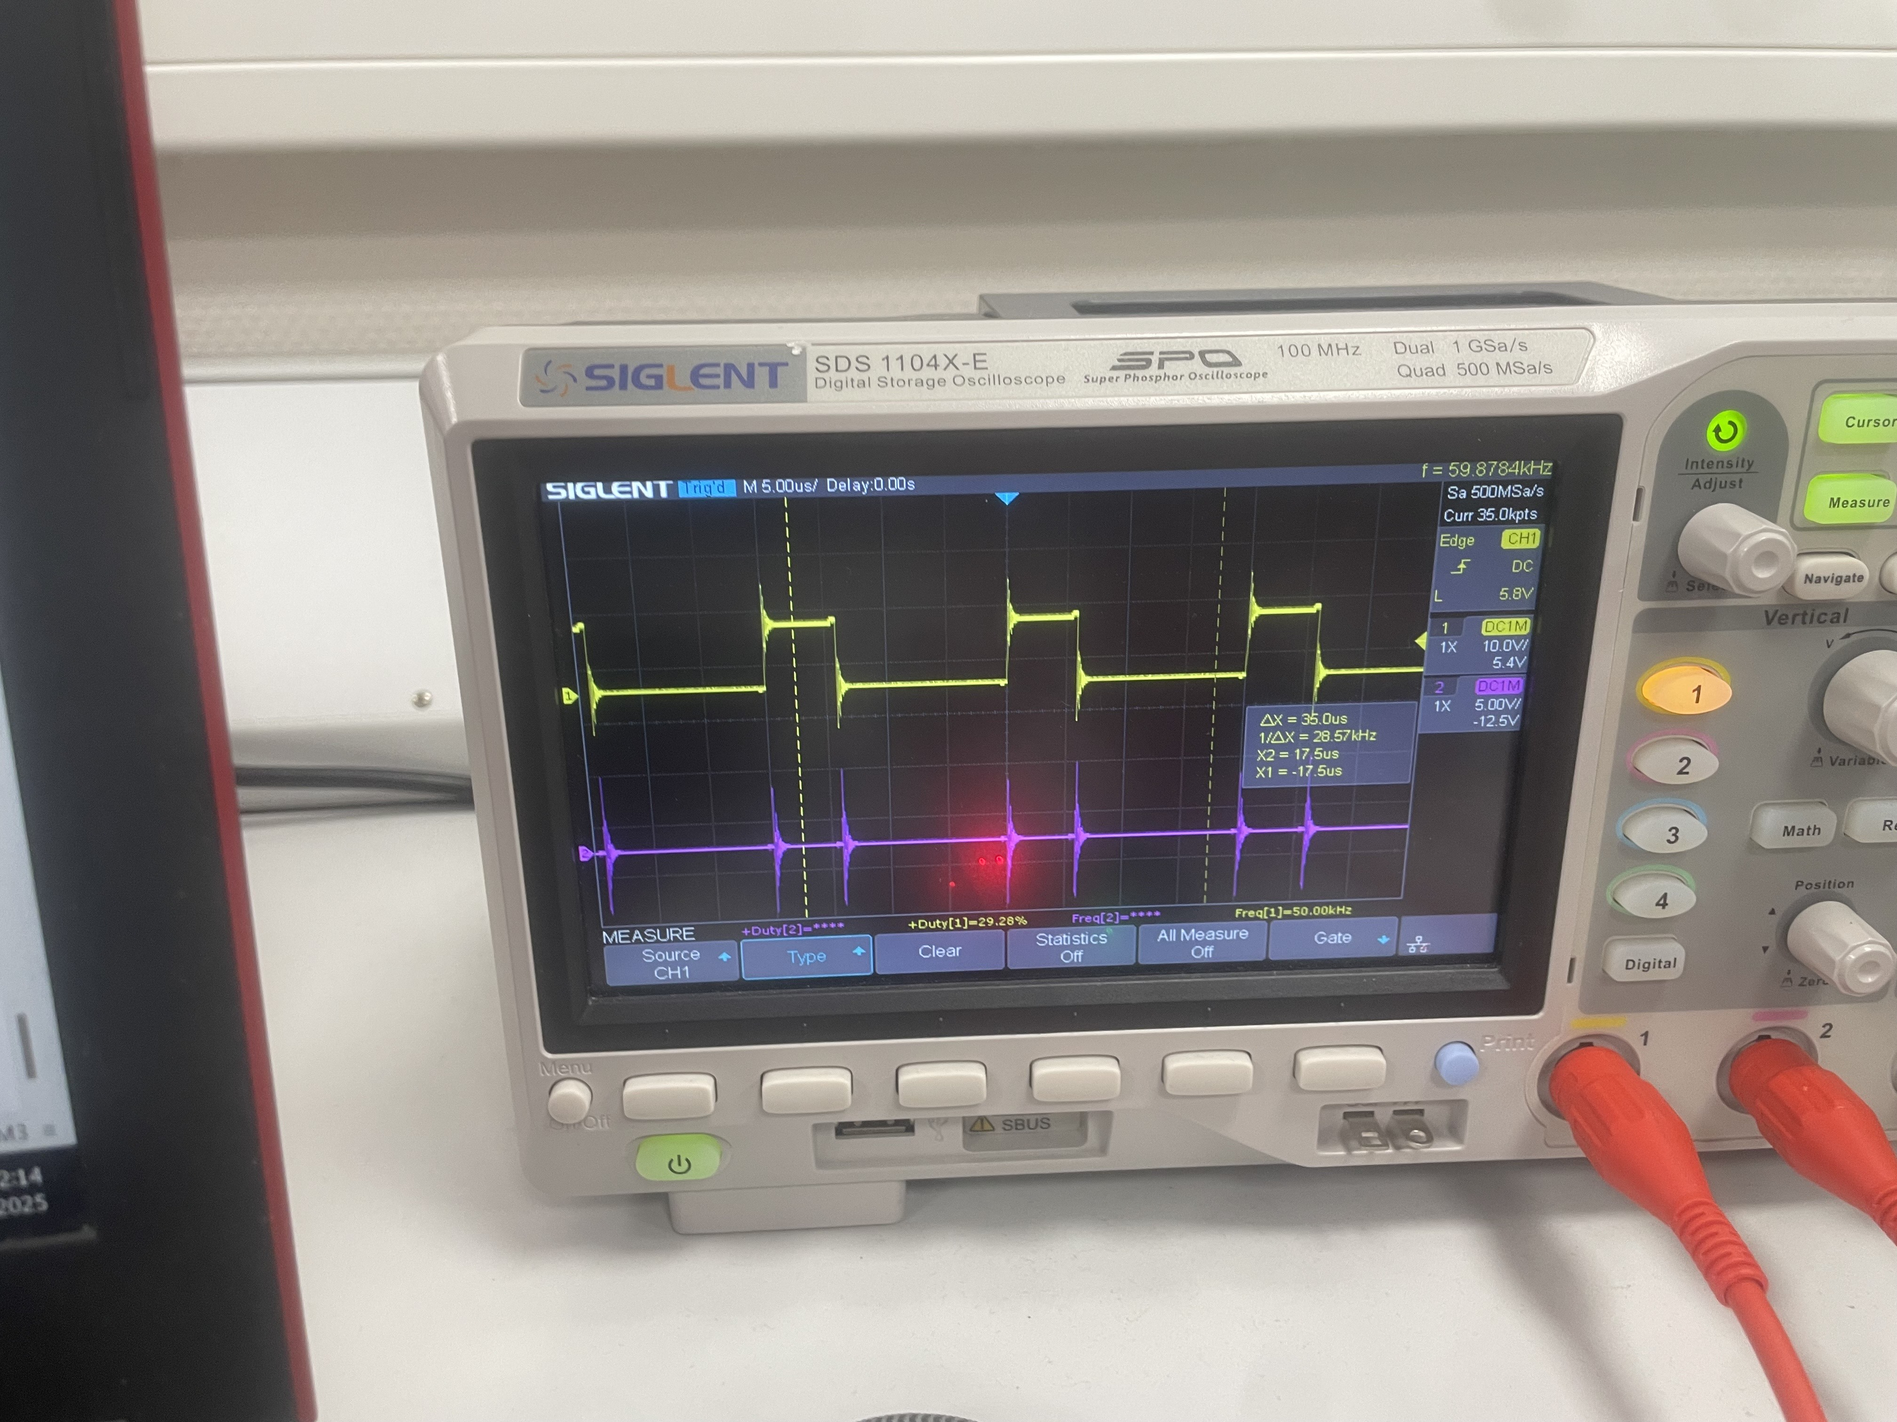

Scope-image at pwm1 = 0, pwm2 = 600.

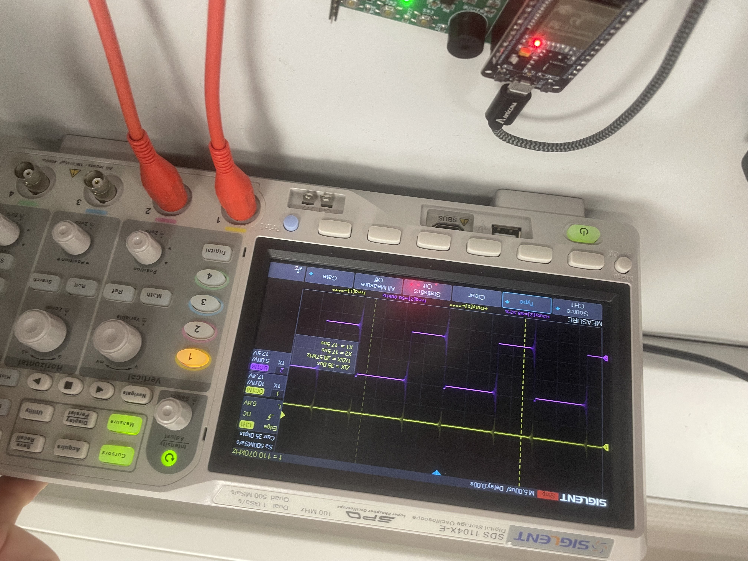

b. Maximum value of duty-cycle input of half-bridge 1 = 996=99.8%

Maximum value of duty-cycle input of half-bridge 2 = -997=97.3%

**Question 18 (4 pnts)**

a. Fill in the table below (encoder frequency and motor current as a function of the duty-cycle input.

|  |  |  |  |  |  |
| --- | --- | --- | --- | --- | --- |
| Half bridge 1 active (pwm2 = 0) | | | Half bridge 2 active (pwm1 = 0) | | |
| duty-cycle | I [A] | Encoder frequency [Hz] | duty-cycle | I[A] | Encoder frequency [Hz] |
| 0 |  |  | 0 |  |  |
| 100 | 0.109 | 251.6 | -100 | -0.102 | -230 |
| 200 | 0.130 | 525.8 | -200 | -0.132 | -510 |
| 300 | 0.137 | 775.8 | -300 | -0.139 | -800 |
| 400 | 0.160 | 1002 | -400 | -0.139 | -1080 |
| 500 | 0.167 | 1434.7 | -500 | -0.153 | -1380 |
| 600 | 0.188 | 1666 | -600 | -0.153 | -1670 |
| 700 | 0.195 | 1838.2 | -700 | -0.176 | -1950 |
| 800 | 0.195 | 1930 | -800 | -0.171 | -2200 |
| 900 | 0.197 | 2105 | -900 | -0.183 | -2550 |

b. Armature resistance = Ra = 1.460445 ohm

Torque constant = km = 0.010963 V·s/rad (== 0.010963 N·m/A)

Script file used to find the armature resistance and torque constant.

*Remark: The script file must also be submitted in a folder named Q18.*

# Q18: PWMs + on-demand encoder & current readout

from time import sleep_ms

from Encoder import GetFrequency

# Objects created in boot.py: HB_ENABLE, pwm1, pwm2, adc_cs

# --- Use measured model from Q16c ---

I0 = -3.8736 # [A]

c2 = 2.3182 # [A/V]

def clamp(n, lo, hi):

return lo if n < lo else hi if n > hi else n

def set_pwm(dc):

"""Map dc (-950..950) to the two legs."""

if dc >= 0:

pwm1.duty(dc); pwm2.duty(0)

else:

pwm1.duty(0); pwm2.duty(-dc)

def read_current_A():

# Use accurate ADC: read_uv -> volts

vcs_V = adc_cs.read_uv() / 1_000_000

return I0 + c2 * vcs_V, vcs_V

print("Q18 ready. Enter duty -950..950. Press ENTER (empty) to read encoder and current.")

HB_ENABLE.value(1) # enable half-bridges (LED2 ON). :contentReference[oaicite:3]{index=3}

while True:

try:

s = input("duty or ENTER to read: ").strip()

# Empty input -> show encoder freq and motor current

if s == "":

f_hz = GetFrequency() # encoder freq (signed by direction) :contentReference[oaicite:4]{index=4}

I_A, vcs_V = read_current_A() # current via I = I0 + c2*VCS :contentReference[oaicite:5]{index=5}

print("Encoder = {:>6.1f} Hz | VCS = {:>5.3f} V | I = {:>+6.3f} A".format(f_hz, vcs_V, I_A))

continue

# Number entered -> set duty

dc = int(s)

dc = clamp(dc, -950, 950)

set_pwm(dc)

# small pause so terminal stays readable

sleep_ms(30)

except KeyboardInterrupt:

print("\nStopping.")

pwm1.duty(0); pwm2.duty(0); HB_ENABLE.value(0)

break

except Exception as e:

print("Please enter an integer in -950..950 (or just press ENTER). Error:", e)

from machine import Pin, PWM, ADC

from Encoder import InitEncoder, GetFrequency # encoder support

# --- Half-bridge enable & ADCs from Q15/16 ---

HB_ENABLE = Pin(13, Pin.OUT) # LED2 mirrors this state

adc_cs = ADC(Pin(32)); adc_cs.atten(ADC.ATTN_11DB); adc_cs.width(ADC.WIDTH_12BIT)

# --- PWMs from Q17 (50 kHz) ---

PWM_FREQ = 50_000

pwm1 = PWM(Pin(25), freq=PWM_FREQ, duty=0) # half-bridge 1

pwm2 = PWM(Pin(26), freq=PWM_FREQ, duty=0) # half-bridge 2

# --- Encoder init for encA=34, encB=35 (run once at boot) ---

InitEncoder(34, 35) # Appendix C says encA/encB on GPIO34/35. :contentReference[oaicite:2]{index=2}

# Start disabled for safety; main.py will enable

HB_ENABLE.value(0)

**Question 19 (4 pnts)**

a. Which signals are involved with I2C?

SCL (clock), SDA (data), both open-drain with pull-ups.

What is an I2C address? What is its range?

Usually **7-bit (0x00–0x7F)**; some reserved. 10-bit exists.

How is the start bit and stop bit of I2C defined?

START = SDA↓ while SCL=1; STOP = SDA↑ while SCL=1.

What is the contents of the first byte of an I2C transfer?

7-bit address (MSB→LSB) + **R/W** bit (0=write, 1=read), then ACK

b. Timing diagram of SCL and SDA when an I2C master writes 1 data (150) to a slave with address 54.

SCL: ┌─┐ ┌─┐ ┌─┐ ┌─┐ ┌─┐ ┌─┐ ┌─┐ ┌─┐ ┌─┐ ┌─┐ ... (clocks)

┘ └─┘ └─┘ └─┘ └─┘ └─┘ └─┘ └─┘ └─┘ └─ └─┘

SDA: [ Address+W = 0b 0 1 1 0 1 1 0 0 ] [A]

0 1 1 0 1 1 0 0 0

[ Data = 0b 1 0 0 1 0 1 1 0 ] [A]

1 0 0 1 0 1 1 0 0

P: STOP (SDA↑ while SCL=1)

c. I2C address of MPU6050 =

- **0x68** when AD0 pin = **0** (default).

- **0x69** when AD0 pin = **1**.

d. How long does it take to read the 3 acceleration forces via a burst read at a baud rate of 400k bit/s.

You read 6 bytes (XH, XL, YH, YL, ZH, ZL) starting at ACCEL_XOUT_H:

Transaction (ideal, no stretching):

* START
* **SLA+W** (1 byte) + **ACK** → 9 bits
* **Register address** (1 byte) + **ACK** → 9 bits
* Repeated START
* **SLA+R** (1 byte) + **ACK** → 9 bits
* **Data**: 6 bytes = 6×8 = 48 bits
* **ACK/NACKs**: 6 bits (ACK after first 5, NACK after last)  
  **Total bits = 9 + 9 + 9 + (48 + 6) = 81 bits**

At **400,000 bits/s**, bit time = **2.5 µs** ⇒  
**81 × 2.5 µs ≈ 202.5 µs ≈ 0.203 ms** (ideal bus time; excludes any clock stretching or firmware overhead).

**Question 20 (3 pnts)**

b. Explain what happens when the following command is executed: i2c.writeto(self.addr, bytearray([107, 1])).

This command **wakes the MPU-6050 and selects the X-gyro PLL as its clock** by writing PWR_MGMT_1 = 0x01.

c. Equation to convert the 16-bits raw data of acceleration to [m/s2] (code line 41 of MPU6050_studentversion.py).

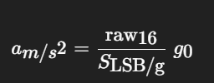

acc_mps2 = (raw / 16384.0) * 9.80665 # for ±2g

d. Equation to calculate the tilt angle [°] (code line 47 of MPU6050_studentversion.py).

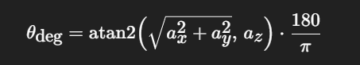

tilt_deg = math.degrees(math.atan2(math.sqrt(ax*ax + ay*ay), az))

e. Fill in the tables below.

|  |  |  |  |  |
| --- | --- | --- | --- | --- |
| Angle MPU6050 board in x-direction [°]1 | Measured tilt angle [°] | acc[0] [m/s2] x | acc[1] [m/s2] y | acc[2] [m/s2] z |
| 0 |  |  |  |  |
| 15 | 11.51 | 9.62 | 0.28 | 1.93 |
| 30 | 27.41 | 8.52 | 0.29 | 4.41 |
| 45 | 45.93 | 7.05 | 0.23 | 7.28 |
| 60 |  |  |  |  |
| 75 | 72.99 | 2.63 | 0.49 | 8.59 |
| 90 | 89.85 | 0.02 | 0 | 9.16 |
| Angle MPU6050 board in y-direction [°] | Measured tilt angle [°] | acc[0] [m/s2] | acc[1] [m/s2] | acc[2] [m/s2] |
| 15 | 14.29 | 9.67 | -2.4 | -0.56 |
| 30 | 28.98 | 8.64 | -4.76 | -0.44 |
| 45 | 43.43 | 7.17 | -6.78 | -0.42 |
| 60 |  |  |  |  |
| 75 | 72.77 | 2.95 | -9.48 | -0.75 |
| 90 | 90.84 | -0.15 | -9.88 | -0.8 |

**Question 21 (2 pnts)**

a. Calculate how long it takes to transmit the string “Hello world” at a baud-rate of 115.2kbit/s, 8 data bits, 1 stop bit and no parity bit

Hello world consists of 10 characters including the space. Every character has 10 bits (1start bit, 8 data bits and 1 stop bit), so the time that it takes to transmit this message is 110/115.2 = 0.955ms

b. Code of main.py. *Remark: All python files of this program must also be submitted in a folder named Q21.*

from machine import UART, Pin, PWM

import time

def now_ms() -> int:

return time.ticks_ms()

class UartConsole:

"""Minimal wrapper around UART for CRLF lines and non-blocking char reads."""

def __init__(self, uart: UART):

self.uart = uart

self._buf1 = bytearray(1)

def read_char(self):

"""Return one byte (int 0..255) if available, else None (non-blocking)."""

n = self.uart.readinto(self._buf1)

if n:

return self._buf1[0]

return None

def send_line(self, text: str):

self.uart.write(text + "\r\n")

class DebouncedButton:

"""

Active-low button with simple debounce.

Use update(ts) on each loop; when it returns True you got a 'pressed' event (rising edge).

"""

def __init__(self, pin: Pin, debounce_ms: int):

self.pin = pin

self.debounce_ms = debounce_ms

self._last_raw = self._pressed_raw()

self._next_ok_ts = 0

def _pressed_raw(self) -> bool:

# Active-low: logic 0 means pressed. Adjust here if hardware differs.

return self.pin.value() == 0

def update(self, ts_ms: int) -> bool:

raw = self._pressed_raw()

if raw != self._last_raw:

# Edge detected

if raw and time.ticks_diff(ts_ms, self._next_ok_ts) >= 0:

# Rising edge into 'pressed'

self._next_ok_ts = time.ticks_add(ts_ms, self.debounce_ms)

self._last_raw = raw

return True

self._next_ok_ts = time.ticks_add(ts_ms, self.debounce_ms)

self._last_raw = raw

return False

class Led:

def __init__(self, pin_no: int, initial=False):

self.pin = Pin(pin_no, Pin.OUT, value=1 if initial else 0)

self.state = bool(initial)

def set(self, on: bool):

self.state = bool(on)

self.pin.value(1 if self.state else 0)

def toggle(self):

self.set(not self.state)

class Buzzer:

def __init__(self, pin_no: int, freq_hz: int, duty_on: int):

self.pwm = PWM(Pin(pin_no))

self.freq_hz = freq_hz

self.duty_on = duty_on

self._on = False

self.off()

def on(self):

self.pwm.freq(self.freq_hz)

self.pwm.duty(self.duty_on)

self._on = True

def off(self):

self.pwm.duty(0)

self._on = False

def toggle(self):

if self._on:

self.off()

else:

self.on()

# Application

class App:

def __init__(self):

# LEDs

self.led_R = Led(PIN_RED, initial=False)

self.led_G = Led(PIN_GREEN, initial=False)

self.led_B = Led(PIN_BLUE, initial=False)

# Buttons

# Note: 36/39 are input-only, external pulls; 15 supports internal pull-up.

self.btn1 = DebouncedButton(Pin(PIN_SW1, Pin.IN), DEBOUNCE_MS)

self.btn2 = DebouncedButton(Pin(PIN_SW2, Pin.IN), DEBOUNCE_MS)

self.btn3 = DebouncedButton(Pin(PIN_SW3, Pin.IN, Pin.PULL_UP), DEBOUNCE_MS)

# Buzzer

self.buzzer = Buzzer(PIN_BUZZER, BUZZER_FREQ_HZ, BUZZER_DUTY_ON)

# UART

self.uart = UartConsole(UART(

UART_ID,

baudrate=UART_BAUDRATE,

bits=UART_BITS,

parity=UART_PARITY,

stop=UART_STOP,

rx=PIN_RX2,

tx=PIN_TX2,

timeout=UART_TIMEOUT, # non-blocking

))

# Command map for UART single-char commands

self._cmd_map = {

ord('R'): self.led_R.toggle,

ord('G'): self.led_G.toggle,

ord('B'): self.led_B.toggle,

ord('A'): self.buzzer.toggle,

}

def _handle_uart(self):

ch = self.uart.read_char()

if ch is None:

return

action = self._cmd_map.get(ch, None)

if action:

action()

# else: ignore unknown chars

def _handle_buttons(self, ts_ms: int):

if self.btn1.update(ts_ms):

self.uart.send_line("switch 1 is pressed")

if self.btn2.update(ts_ms):

self.uart.send_line("switch 2 is pressed")

if self.btn3.update(ts_ms):

self.uart.send_line("switch 3 is pressed")

def run(self):

# Reuse a single loop delay to stay responsive yet lightweight

while True:

ts = now_ms()

self._handle_uart()

self._handle_buttons(ts)

time.sleep_ms(LOOP_SLEEP_MS)

# Entry point

if __name__ == "__main__":

App().run()

**Question 22 (3 pnts)**

Code of main.py to test the tilt protection.

*Remark: All python files of this program must also be submitted in a folder named Q22.*

from machine import Pin, PWM, UART, SoftI2C

import time

from HighLevelController import HighLevelController, reg

from MPU6050_studentversion import MPU6050

def set_leds(green_on: bool, red_on: bool):

led_green.value(1 if green_on else 0)

led_red.value(1 if red_on else 0)

def buzzer_on(on: bool):

# MicroPython ESP32 PWM: duty 0..1023 (classic API). 0 = off.

buzzer.duty(512 if on else 0)

# ---- Devices ----

mpu = MPU6050(i2c) # wakes MPU6050 in its constructor

hlc = HighLevelController(uart2, None) # TCP not used in Q22

# ---- Core function required by Q22 ----

def TiltAngle():

"""

- Read accelerations and tilt from MPU6050

- Store in reg[3..6] with correct units (Appendix E)

acc in mm/s^2 (int), tilt in degrees (int)

- Compare against reg[20] (warn) and reg[21] (error)

-> LEDs & buzzer logic per spec

"""

tilt_deg = mpu.tiltAngle()

ax, ay, az = mpu.acc # in m/s^2 from studentversion driver

# Write registers (Appendix E):

reg[3] = int(round(ax * 1000)) # mm/s^2

reg[4] = int(round(ay * 1000)) # mm/s^2

reg[5] = int(round(az * 1000)) # mm/s^2

reg[6] = int(round(tilt_deg)) # degrees

warn = reg[20] # Tilt angle warning level [°]; 0 disables warning

err = reg[21] # Tilt angle error level [°]; 0 disables error

# --- Warning LEDs ---

if warn == 0:

# Warning system disabled -> both LEDs off

set_leds(green_on=False, red_on=False)

else:

if tilt_deg < warn:

# OK region -> green on, red off

set_leds(green_on=True, red_on=False)

else:

# Warning exceeded -> red on, green off

set_leds(green_on=False, red_on=True)

# --- Error (buzzer) ---

if err == 0:

buzzer_on(False)

else:

buzzer_on(tilt_deg >= err)

# ---- 100 ms scheduler loop (exact period) ----

PERIOD_MS = 100

next_tick = time.ticks_add(time.ticks_ms(), PERIOD_MS)

while True:

# Run the tilt protection function

TiltAngle()

# Service UART protocol (read/write to reg[] as needed)

hlc.readFromUart()

# Keep exactly 100 ms period

now = time.ticks_ms()

# if we're late, jump to next slot to avoid drift

if time.ticks_diff(next_tick, now) <= 0:

next_tick = time.ticks_add(now, PERIOD_MS)

else:

time.sleep_ms(time.ticks_diff(next_tick, now))

next_tick = time.ticks_add(next_tick, PERIOD_MS)

**Question 23 (4 pnts)**

Code of main.py to test the TCP communication.

*Remark: All python files of this program must also be submitted in a folder named Q23.*

from machine import Pin

from time import sleep_ms

from TCPHandler import TCPHandler

# WiFi network credentials

SSID = 'Kurwa' # <-- your WiFi SSID

PASSWORD = '12345679' # <-- your WiFi password

PORT = 5000

# LED on Pin 2 turns on when a client connects

tcp = TCPHandler(SSID, PASSWORD, PORT, led=Pin(2))

print("TCP square server started. Waiting for client connection...")

while True:

state = tcp.getState()

if state == 0: # not connected to WiFi

sleep_ms(100)

continue

elif state == 1: # WiFi connected (no client)

sleep_ms(100)

continue

elif state == 2: # client connected

data = tcp.receive() # <-- correct method name

if not data:

sleep_ms(50)

continue

# Convert bytes -> str

try:

text = data.decode().strip()

except Exception:

text = ""

# Try to parse number and respond

try:

value = float(text)

square = value ** 2

tcp.transmit(str(square)) # <-- correct method name

except ValueError:

tcp.transmit("Error: invalid number")

sleep_ms(50)

**Question 24 (14 pnts)**

Contents of main.py. *Remark: all script files of this program must also be submitted in a folder named Q24.*

#Q24

from machine import Pin, PWM, ADC, SoftI2C, UART

from time import ticks_ms, ticks_add, ticks_diff, sleep_ms

from HighLevelController1 import HighLevelController, reg

from TCPHandler import TCPHandler

from MPU6050_studentversion import MPU6050

import Encoder

import time

SSID = "Kurwa"

PASSWORD = "12345679"

PORT = 5000

tcp = TCPHandler(SSID, PASSWORD, PORT, led=Pin(2))

hlc = HighLevelController(uart2, tcp)

# Wait for TCP server to be ready (so port 5000 opens)

print("Waiting for TCP server to start...")

tcp_state = 0

for _ in range(150): # ~15 s max

tcp_state = tcp.getState() # 0: Wi-Fi connecting, 1: listening, 2: client connected

if tcp_state >= 1:

break

time.sleep_ms(100)

print("TCP state at start:", tcp_state)

# ----------- Sensors -----------

mpu = MPU6050(i2c, addr=0x68, up_axis='x', up_sign=+1)

Encoder.InitEncoder(ENC_A, ENC_B)

# ----------- Motor / model constants (regs 13..19) -----------

# Encoder is 16 CPR (cycles/rev) on the MOTOR shaft; gearbox 48:1.

reg[13] = 16 # CPR at motor shaft (match Q18)

reg[14] = 21 # gear ratio ×1000 => (1/48)*1000 ≈ 20.833 -> 21

reg[15] = 250 # rated shaft speed [rpm] (placeholder; update if you have datasheet value)

# Torque model (from your Q18b): km ≈ 10.963 mNm/A, choose Irated=200 mA -> Trated ≈ 2.193 mNm

reg[16] = 2193 # rated torque [mNm]

reg[17] = 200 # rated current [mA]

# From Q18 / Q18b

reg[18] = 160 # no-load current @ ~½ speed [mA]

reg[19] = 1460 # armature resistance [mΩ] (1.460445 Ω)

# Tilt thresholds (modifiable over HLC)

reg[20] = 15 # warn [°]

reg[21] = 30 # error [°]

# VS path: ~5:1 divider to 0..3.0 V range

VS_MV_PER_COUNT = (3000 * 5) / 4095.0 # ≈ 3.663 mV/count at battery

# Current sensor linear fit from ±I tables:

# I[mA] = I0_MA + C2_MA_PER_MV * Vcs[mV]

I0_MA = -3896.0

C2_MA_PER_MV = 2.33

def read_battery_mV():

return int(VS_ADC.read() * VS_MV_PER_COUNT)

def read_current_mA():

vcs_mV = (CS_ADC.read() * 3000.0) / 4095.0

return int(round(I0_MA + C2_MA_PER_MV * vcs_mV))

def apply_pwm_from_reg(pwm_obj, cmd_0_1023):

"""Accept 0..1023 in reg and apply to PWM (works on duty_u16 or duty)."""

if cmd_0_1023 < 0: cmd_0_1023 = 0

if cmd_0_1023 > 1023: cmd_0_1023 = 1023

if hasattr(pwm_obj, "duty_u16"):

pwm_obj.duty_u16(int((cmd_0_1023 / 1023.0) * 65535))

else:

pwm_obj.duty(cmd_0_1023)

def tilt_protection():

"""LEDs + buzzer + EN control based on tilt thresholds; publish acc/tilt regs."""

tilt = mpu.tiltAngle()

ax, ay, az = mpu.acc # m/s^2

# publish to registers

reg[3] = int(round(ax * 1000)) # mm/s^2

reg[4] = int(round(ay * 1000))

reg[5] = int(round(az * 1000))

reg[6] = int(round(tilt)) # deg

warn = reg[20]

err = reg[21]

# LEDs

if warn == 0:

LED_G.value(0); LED_R.value(0)

else:

if tilt < warn:

LED_G.value(1); LED_R.value(0)

else:

LED_G.value(0); LED_R.value(1)

# Error: buzzer + disable H-bridge

if err and tilt >= err:

buzzer.duty_u16(20000) # on

EN.value(0) # disable power stage

else:

buzzer.duty_u16(0)

EN.value(1) # allowed

def compute_speed_torque(current_mA, freq_Hz):

"""

freq_Hz: signed cycles/sec from a 16-CPR encoder on the MOTOR shaft (like Q18)

motor_rpm = (freq * 60) / 16

shaft_rpm = motor_rpm * (reg[14]/1000) ~ divide by 48

"""

motor_rpm = (freq_Hz * 60.0) / 16.0

shaft_rpm = motor_rpm * (reg[14] / 1000.0)

# no-load current sign follows direction

I0 = reg[18] if shaft_rpm >= 0 else -reg[18]

kT = (reg[16] / float(reg[17])) if reg[17] else 0.0 # mNm/mA

Tshaft_mNm = kT * (current_mA - I0)

return int(round(shaft_rpm)), int(round(Tshaft_mNm))

PERIOD_MS = 100

reg[22] = 0 # pwm1 command 0..1023

reg[23] = 0 # pwm2 command 0..1023

print("Q24 starting...")

next_t = ticks_add(ticks_ms(), PERIOD_MS)

while True:

# Keep TCP state machine alive (listening / accept clients)

tcp.getState()

# sensors → regs[0..2]

reg[0] = read_battery_mV() # mV

reg[1] = read_current_mA() # mA

freq = Encoder.GetFrequency() # Hz (signed; same as Q18)

reg[2] = int(freq)

# tilt protection (also sets EN/buzzer), publish acc/tilt regs

tilt_protection()

# derive speed & torque → regs[7..8]

rpm_shaft, Tshaft = compute_speed_torque(reg[1], freq)

reg[7] = rpm_shaft

reg[8] = Tshaft

# serve protocols

hlc.readFromTCP() # TCP client (KiTTY)

hlc.readFromUart() # UART2 client, if used

# apply PWM commands from reg[22]/[23] (0..1023)

apply_pwm_from_reg(PWM1, reg[22])

apply_pwm_from_reg(PWM2, reg[23])

# exact 100 ms cadence

now = ticks_ms()

dt = ticks_diff(next_t, now)

if dt > 0:

sleep_ms(dt)

next_t = ticks_add(next_t, PERIOD_MS)

else:

next_t = ticks_add(now, PERIOD_MS)

**Question 25 (10 pnts)**

Fill int the tables below

|  |  |  |  |
| --- | --- | --- | --- |
| Speed setpoint [rpm] | Speed shaft [rpm] | Encoder  frequency [Hz] | Difference speed setpoint and speed shaft [%] |
| 25 | 25 | 293 | 0% |
| 50 | 51 | 565 | 2% |
| 100 | 99 | 1155 | -1% |
| 150 | 152 | 1720 | 1.3% |
| 200 | 202 | 2301 | 1% |
| 250 | 252 | 2900 | 0.8% |
| -25 | -26 | 290 | 4% |
| -50 | -50 | 570 | 0% |
| -100 | -99 | 1170 | -1% |
| -150 | -152 | 1730 | 1.3% |
| -200 | -198 | 2289 | -1% |
| -250 | -252 | 2889 | 0.8% |

|  |  |  |  |
| --- | --- | --- | --- |
| Torque limit [mNm] | Torque at shaft [mNm] | Motor current [mA] | Difference torque limit and measured torque [%] |
| Speed setpoint= 50 [rpm] | | | |
| 50 | 50 | 552 mA | 0% |
| 100 | 100 | 1009 mA | 0% |
| 150 | 150 | 1466 mA | 0% |
| 200 | 201 | 1931 mA | 0.5% |
| Speed setpoint= -50 [rpm] | | | |
| 50 | - 47 | -326 mA | -6% |
| 100 | - 97 | -789 mA | -3% |
| 150 | - 140 | -1375 mA | -6.7% |
| 200 | - 196 | -1683 mA | -2% |

The measurements are done at 0rpm (STALL zone)

Contents of main.py. *Remark: all script files of this program must also be submitted in a folder named Q25.*

from boot import * # pins, PWM1/PWM2, EN, LEDs, ADCs, uart2, i2c, etc.

from machine import Pin

from time import ticks_ms, ticks_add, ticks_diff, sleep_ms

from HighLevelController1 import HighLevelController, reg

from TCPHandler import TCPHandler

from MPU6050_studentversion import MPU6050

import Encoder

import time

# ---------------- Network / protocol ----------------

SSID = "Kurwa"

PASSWORD = "12345679"

PORT = 5000

tcp = TCPHandler(SSID, PASSWORD, PORT, led=Pin(2))

hlc = HighLevelController(uart2, tcp)

print("Waiting for TCP server to start.")

for _ in range(150): # about 15 seconds

if tcp.getState() >= 1: # 0: Wi-Fi, 1: listening, 2: client connected

break

time.sleep_ms(100)

# ---------------- Sensors ----------------

mpu = MPU6050(i2c, addr=0x68, up_axis='x', up_sign=+1)

Encoder.InitEncoder(ENC_A, ENC_B) # returns signed hertz on GetFrequency()

# ---------------- Motor / model constants ----------------

reg[13] = 16 # cycles per motor revolution at motor

reg[14] = 23 # gear ratio times one thousand (= 1/43.7)

reg[15] = 250 # rated shaft speed [rpm]

reg[16] = 318 # rated torque [mN·m]

reg[17] = 2900 # rated current [mA]

reg[18] = 100 # no-load current near half speed [mA]

reg[19] = 1460 # armature resistance [mΩ] (1.460 Ω)

# ---------------- Tilt thresholds ----------------

reg[20], reg[21] = 15, 30

# ---------------- ADC calibration ----------------

VS_MV_PER_COUNT = (3300 * 5) / 4095.0 # battery divider about five to one

# Current sensor calibration (auto-zero + selectable polarity)

C2_MA_PER_MV = 2.33 # slope magnitude

CURR_SIGN = +1 # set each loop from reg[26]

CURR_VREF_MV = None # learned zero (idle) voltage

current_filt = 0.0 # filtered current (mA) for torque

def calibrate_current_zero(samples=64):

global CURR_VREF_MV

acc = 0

for _ in range(samples):

acc += CS_ADC.read()

time.sleep_ms(5)

CURR_VREF_MV = (acc / samples) * (3300.0 / 4095.0)

def read_battery_mV():

return int(VS_ADC.read() * VS_MV_PER_COUNT)

def read_current_mA():

"""Read raw sensor, convert to milliampere, then apply a simple low-pass filter."""

global CURR_VREF_MV, current_filt

if CURR_VREF_MV is None:

calibrate_current_zero()

vcs_mV = (CS_ADC.read() * 3300.0) / 4095.0

i_now = CURR_SIGN * C2_MA_PER_MV * (vcs_mV - CURR_VREF_MV)

# Low-pass: 90 percent previous + 10 percent new

current_filt = 0.9 * current_filt + 0.1 * i_now

return int(round(current_filt))

# ---------------- Helpers ----------------

def apply_pwm_from_reg(pwm_obj, cmd_0_1023):

if cmd_0_1023 < 0: cmd_0_1023 = 0

if cmd_0_1023 > 1023: cmd_0_1023 = 1023

if hasattr(pwm_obj, "duty_u16"):

pwm_obj.duty_u16(int((cmd_0_1023 / 1023.0) * 65535))

else:

pwm_obj.duty(cmd_0_1023)

def set_duty_fraction(duty):

duty = max(-0.98, min(0.98, duty))

if duty >= 0:

reg[23] = 0

reg[22] = int(round(duty * 1023))

else:

reg[22] = 0

reg[23] = int(round((-duty) * 1023))

def get_duty_fraction():

if reg[22] > 0 and reg[23] == 0:

return min(0.98, reg[22] / 1023.0)

if reg[23] > 0 and reg[22] == 0:

return -min(0.98, reg[23] / 1023.0)

return 0.0

# --- Tilt protection with small hysteresis; only DISABLES the bridge

tilt_in_fault = False # latched fault with hysteresis

def tilt_protection():

"""Update tilt registers, light indicators, and buzzer.

Return True when fault (bridge must be disabled), False otherwise.

This function never enables the bridge; it may only force-disable it."""

global tilt_in_fault

tilt = mpu.tiltAngle()

ax, ay, az = mpu.acc

reg[3] = int(round(ax * 1000))

reg[4] = int(round(ay * 1000))

reg[5] = int(round(az * 1000))

reg[6] = int(round(tilt))

warn, err = reg[20], reg[21]

# Warning indicators

if warn == 0:

LED_G.value(0); LED_R.value(0)

else:

if tilt < warn: LED_G.value(1); LED_R.value(0)

else: LED_G.value(0); LED_R.value(1)

# Fault latch with two degree hysteresis

if err:

if tilt_in_fault:

if tilt < (err - 2):

tilt_in_fault = False

else:

if tilt >= err:

tilt_in_fault = True

else:

tilt_in_fault = False

# Buzzer and enforced disable on fault

if tilt_in_fault:

buzzer.duty_u16(20000)

EN.value(0)

else:

buzzer.duty_u16(0)

return tilt_in_fault

def cycles_to_rpm_shaft(cycles_hz):

cpr = reg[13] if reg[13] else 16

motor_rpm = (cycles_hz * 60.0) / float(cpr)

return int(round(motor_rpm * (reg[14] / 1000.0)))

def compute_torque_mNm(current_mA, rpm_shaft):

"""

Return SIGNED shaft torque.

Convention used here:

- Positive torque when it assists the current direction of rotation.

- Negative torque when it opposes the rotation (braking).

Implementation:

τ = kT * (I - sgn(ω)*I0), then we align sign with rotation: τ_signed = sgn(ω) * τ

"""

# motor torque constant in mN·m per mA

kT = (reg[16] / float(reg[17])) if reg[17] else 0.0

# sign of rotation (+1 for ≥0 rpm, -1 for <0 rpm)

s_omega = 1 if rpm_shaft >= 0 else -1

# direction-aware no-load current

I0 = s_omega * reg[18]

# raw torque (can be positive or negative)

tau = kT * (current_mA - I0)

# torque signed with rotation direction

tau_signed = s_omega * tau

# small symmetric deadband to kill tiny noise around zero

if abs(tau_signed) < 5:

return 0

return int(round(tau_signed))

# ---------------- Q25 controller ----------------

MODE_OFF = 0

MODE_TEST = 1

MODE_CTRL = 2

# defaults

reg[9] = MODE_OFF # start in off mode

reg[10] = 50 # speed setpoint [rpm]

reg[11] = reg[16] # torque limit [mN·m] (start at rated torque)

reg[26] = 1 # current polarity control: >0 => positive, <0 => negative

TS = 0.1 # loop period [s]

KI = 0.016 # integral gain tuned for the required ramp

RPM_ALPHA = 0.2 # speed low-pass weight

rpm_filt = 0.0

duty_int = 0.0

def i_controller_step(rpm_set, rpm_meas, vin_mV, i_meas_mA, enabled=True):

"""

Integral-only controller with current-based duty limiting.

Direction guard: duty sign follows setpoint sign; never crosses zero.

"""

global duty_int

# When disabled, bleed integrator and keep sign guard

if not enabled:

duty_int *= 0.9

# guard against tiny sign creep

if rpm_set >= 0 and duty_int < 0: duty_int = 0.0

if rpm_set < 0 and duty_int > 0: duty_int = 0.0

return duty_int

# 1) Integral step

error = rpm_set - rpm_meas

delta_dc = KI * error * TS

# 2) Current/torque limiter (caps the permitted delta toward limit)

kT = (reg[16] / float(reg[17])) if reg[17] else 1e-6

I0 = reg[18] if rpm_set >= 0 else -reg[18]

Imax = (reg[11] / kT) + I0 # [mA]

Ra = reg[19] / 1000.0 # [Ohm]

Uin = max(1.0, vin_mV / 1000.0) # [V]

if rpm_set >= 0:

# When over limit (i_meas > Imax), limiter allows negative delta to back off,

# but the direction guard (below) will stop at zero.

delta_dc = min(delta_dc, (Ra * (Imax - i_meas_mA)) / Uin)

else:

delta_dc = max(delta_dc, -(Ra * (Imax + i_meas_mA)) / Uin)

# 3) Accumulate

duty_int += delta_dc

# 4) Direction guard + anti-windup at bound

if rpm_set >= 0:

if duty_int < 0.0:

duty_int = 0.0 # do not cross into negative

if duty_int > 0.98:

duty_int = 0.98 # top clamp

else:

if duty_int > 0.0:

duty_int = 0.0 # do not cross into positive

if duty_int < -0.98:

duty_int = -0.98 # bottom clamp

return duty_int

# ---------------- Telemetry (UART2) ----------------

reg[27] = 1 # 1 = telemetry on, 0 = off

TELEMETRY_EVERY_N = 5 # one line every 5 loops (~2 Hz at 100 ms)

telemetry_counter = 0

def send_telemetry(timestamp_ms):

"""CSV to uart2: tel,<seconds>,<rpm>,<mN·m>,<mA>"""

try:

s = "tel,{:.3f},{},{},{}\n".format(

timestamp_ms / 1000.0,

int(reg[7]), # speed (rpm)

int(reg[8]), # torque (mN·m)

int(reg[1]) # current (mA) <-- added

)

uart2.write(s)

except Exception:

pass

# -------------- Encoder sign stabilization --------------

last_sign = +1

sign_streak = 0

RPM_SIGN_MIN = 20 # do not accept sign changes below this speed (rpm)

SIGN_HOLD_SAMPLES = 3 # need this many consecutive samples to flip sign

# ---------------- Main loop ----------------

PERIOD_MS = 100

reg[22] = 0

reg[23] = 0

# Ensure auto-zero happens at rest

calibrate_current_zero()

print("Q25 starting.")

next_t = ticks_add(ticks_ms(), PERIOD_MS)

while True:

tcp.getState() # keep server alive

# Sensors -> registers

reg[0] = read_battery_mV()

# current polarity from reg[26]

CURR_SIGN = 1 if reg[26] >= 0 else -1

reg[1] = read_current_mA()

# Encoder frequency (signed hertz)

freq_hz = Encoder.GetFrequency()

reg[2] = int(freq_hz) # signed frequency

# Tilt protection (may force-disable)

tilt_fault = tilt_protection()

# ---------- Derived signals with sign stabilization ----------

rpm_mag = cycles_to_rpm_shaft(abs(freq_hz)) # non-negative magnitude

cand_sign = +1 if freq_hz >= 0 else -1

# Only allow sign change if speed is clearly nonzero and sustained

if rpm_mag >= RPM_SIGN_MIN and cand_sign != last_sign:

sign_streak += 1

if sign_streak >= SIGN_HOLD_SAMPLES:

last_sign = cand_sign

sign_streak = 0

else:

sign_streak = 0

rpm_signed = rpm_mag if last_sign > 0 else -rpm_mag

reg[7] = int(rpm_signed) # signed shaft rpm

reg[8] = compute_torque_mNm(reg[1], reg[7]) # uses filtered current

# ------------------------------------------------------------

# Telemetry at limited rate

if reg[27]:

telemetry_counter = (telemetry_counter + 1) % TELEMETRY_EVERY_N

if telemetry_counter == 0:

send_telemetry(ticks_ms())

# Filtered rpm for controller stability (on signed rpm)

rpm_filt += RPM_ALPHA * (reg[7] - rpm_filt)

# Commands from host

hlc.readFromTCP()

hlc.readFromUart()

# -------- Modes --------

m = reg[9]

if m == MODE_OFF:

duty_int = 0.0

reg[22] = 0; reg[23] = 0

EN.value(0) # keep disabled in OFF

elif m == MODE_TEST:

# manual pulse width, ensure exclusivity

if reg[22] > 0: reg[23] = 0

if reg[23] > 0: reg[22] = 0

duty_int = get_duty_fraction() # track for smooth switching

EN.value(0 if tilt_fault else 1)

elif m == MODE_CTRL:

duty = i_controller_step(

rpm_set = reg[10],

rpm_meas = rpm_filt,

vin_mV = reg[0],

i_meas_mA = reg[1],

enabled = (not tilt_fault)

)

set_duty_fraction(duty)

EN.value(0 if tilt_fault else 1)

else:

# unknown mode -> safe

duty_int = 0.0

reg[22] = 0; reg[23] = 0

EN.value(0)

# Apply to hardware

apply_pwm_from_reg(PWM1, reg[22])

apply_pwm_from_reg(PWM2, reg[23])

# 100 ms cadence

now = ticks_ms()

dt = ticks_diff(next_t, now)

if dt > 0:

sleep_ms(dt); next_t = ticks_add(next_t, PERIOD_MS)

else:

next_t = ticks_add(now, PERIOD_MS)

**Question 26 (10 pnts)**

Contents of main.py. *Remark: all script files of this program must also be submitted in a folder named Q26.*

from boot import * # pins, PWM1/PWM2, EN, LEDs, ADCs, uart2, i2c, SW1/SW2/SW3, etc.

from machine import Pin

from time import ticks_ms, ticks_add, ticks_diff, sleep_ms

from HighLevelController1 import HighLevelController, reg

from TCPHandler import TCPHandler

from MPU6050_studentversion import MPU6050

import Encoder

import time

# ---------------- Network / protocol ----------------

SSID = "Kurwa"

PASSWORD = "12345679"

PORT = 5000

tcp = TCPHandler(SSID, PASSWORD, PORT, led=Pin(2))

hlc = HighLevelController(uart2, tcp)

print("Waiting for TCP server to start.")

for _ in range(150): # about 15 seconds

if tcp.getState() >= 1: # 0: Wi-Fi, 1: listening, 2: client connected

break

time.sleep_ms(100)

# ---------------- Sensors ----------------

mpu = MPU6050(i2c, addr=0x68, up_axis='x', up_sign=+1)

Encoder.InitEncoder(ENC_A, ENC_B) # returns signed hertz on GetFrequency()

# ---------------- Motor / model constants ----------------

reg[13] = 16 # cycles per motor revolution at motor

reg[14] = 23 # gear ratio ×1000 (= 1/43.7)

reg[15] = 250 # rated shaft speed [rpm]

reg[16] = 318 # rated torque [mN·m]

reg[17] = 2900 # rated current [mA]

reg[18] = 100 # no-load current [mA]

reg[19] = 1460 # armature resistance [mΩ] (1.460 Ω)

# ---------------- Tilt thresholds ----------------

reg[20], reg[21] = 30, 45

# ---------------- ADC calibration ----------------

VS_MV_PER_COUNT = (3300 * 5) / 4095.0 # battery divider about five to one

# Current sensor calibration

C2_MA_PER_MV = 2.33

CURR_SIGN = +1

CURR_VREF_MV = None

current_filt = 0.0

def calibrate_current_zero(samples=64):

global CURR_VREF_MV

acc = 0

for _ in range(samples):

acc += CS_ADC.read()

time.sleep_ms(5)

CURR_VREF_MV = (acc / samples) * (3300.0 / 4095.0)

def read_battery_mV():

return int(VS_ADC.read() * VS_MV_PER_COUNT)

def read_current_mA():

"""Read current sensor and filter."""

global CURR_VREF_MV, current_filt

if CURR_VREF_MV is None:

calibrate_current_zero()

vcs_mV = (CS_ADC.read() * 3300.0) / 4095.0

i_now = CURR_SIGN * C2_MA_PER_MV * (vcs_mV - CURR_VREF_MV)

current_filt = 0.9 * current_filt + 0.1 * i_now

return int(round(current_filt))

# ---------------- Helpers ----------------

def apply_pwm_from_reg(pwm_obj, cmd_0_1023):

cmd_0_1023 = max(0, min(1023, cmd_0_1023))

if hasattr(pwm_obj, "duty_u16"):

pwm_obj.duty_u16(int((cmd_0_1023 / 1023.0) * 65535))

else:

pwm_obj.duty(cmd_0_1023)

def set_duty_fraction(duty):

duty = max(-0.98, min(0.98, duty))

if duty >= 0:

reg[23] = 0

reg[22] = int(round(duty * 1023))

else:

reg[22] = 0

reg[23] = int(round((-duty) * 1023))

def get_duty_fraction():

if reg[22] > 0 and reg[23] == 0:

return min(0.98, reg[22] / 1023.0)

if reg[23] > 0 and reg[22] == 0:

return -min(0.98, reg[23] / 1023.0)

return 0.0

# --- Tilt protection ---

tilt_in_fault = False

def tilt_protection():

"""Read tilt, drive LEDs, buzzer, and disable on fault."""

global tilt_in_fault

tilt = mpu.tiltAngle()

ax, ay, az = mpu.acc

reg[3] = int(round(ax * 1000))

reg[4] = int(round(ay * 1000))

reg[5] = int(round(az * 1000))

reg[6] = int(round(tilt))

warn, err = reg[20], reg[21]

if warn == 0:

LED_G.value(0); LED_R.value(0)

else:

if tilt < warn: LED_G.value(1); LED_R.value(0)

else: LED_G.value(0); LED_R.value(1)

# Fault latch with hysteresis

if err:

if tilt_in_fault:

if tilt < (err - 2):

tilt_in_fault = False

else:

if tilt >= err:

tilt_in_fault = True

else:

tilt_in_fault = False

if tilt_in_fault:

buzzer.duty_u16(20000)

EN.value(0)

else:

buzzer.duty_u16(0)

return tilt_in_fault

def cycles_to_rpm_shaft(cycles_hz):

cpr = reg[13] if reg[13] else 16

motor_rpm = (cycles_hz * 60.0) / float(cpr)

return int(round(motor_rpm * (reg[14] / 1000.0)))

def compute_torque_mNm(current_mA, rpm_shaft):

"""Compute signed shaft torque."""

kT = (reg[16] / float(reg[17])) if reg[17] else 0.0

s_omega = 1 if rpm_shaft >= 0 else -1

I0 = s_omega * reg[18]

tau = kT * (current_mA - I0)

tau_signed = s_omega * tau

if abs(tau_signed) < 5:

return 0

return int(round(tau_signed))

# ---------------- Q25 controller ----------------

MODE_OFF = 0

MODE_TEST = 1

MODE_CTRL = 2

reg[9] = MODE_OFF

reg[10] = 50

reg[11] = reg[16]

reg[26] = 1

TS = 0.1

KI = 0.016

RPM_ALPHA = 0.2

rpm_filt = 0.0

duty_int = 0.0

def i_controller_step(rpm_set, rpm_meas, vin_mV, i_meas_mA, enabled=True):

global duty_int

if not enabled:

duty_int *= 0.9

if rpm_set >= 0 and duty_int < 0: duty_int = 0.0

if rpm_set < 0 and duty_int > 0: duty_int = 0.0

return duty_int

error = rpm_set - rpm_meas

delta_dc = KI * error * TS

kT = (reg[16] / float(reg[17])) if reg[17] else 1e-6

I0 = reg[18] if rpm_set >= 0 else -reg[18]

Imax = (reg[11] / kT) + I0

Ra = reg[19] / 1000.0

Uin = max(1.0, vin_mV / 1000.0)

if rpm_set >= 0:

delta_dc = min(delta_dc, (Ra * (Imax - i_meas_mA)) / Uin)

else:

delta_dc = max(delta_dc, -(Ra * (Imax + i_meas_mA)) / Uin)

duty_int += delta_dc

if rpm_set >= 0:

duty_int = min(0.98, max(0.0, duty_int))

else:

duty_int = max(-0.98, min(0.0, duty_int))

return duty_int

# -------------- Encoder sign stabilization --------------

last_sign = +1

sign_streak = 0

RPM_SIGN_MIN = 20

SIGN_HOLD_SAMPLES = 3

# -------------- Buttons (use SW1/SW2/SW3 from boot.py) --------------

# Active-low convention: 1 = released, 0 = pressed

prev_sw1 = SW1.value()

prev_sw2 = SW2.value()

prev_sw3 = SW3.value()

DEBOUNCE_MS = 30

last_sw1_time = 0

last_sw2_time = 0

last_sw3_time = 0

def _pressed(prev, now):

return (prev == 1) and (now == 0) # falling edge on active-low

last_active_mode = MODE_TEST # remembered for SW1 toggle

# ---------------- Main loop ----------------

PERIOD_MS = 100

reg[22] = 0

reg[23] = 0

calibrate_current_zero()

print("Q25 starting.")

next_t = ticks_add(ticks_ms(), PERIOD_MS)

while True:

tcp.getState()

# Sensors

reg[0] = read_battery_mV()

CURR_SIGN = 1 if reg[26] >= 0 else -1

reg[1] = read_current_mA()

freq_hz = Encoder.GetFrequency()

reg[2] = int(freq_hz)

tilt_fault = tilt_protection()

rpm_mag = cycles_to_rpm_shaft(abs(freq_hz))

cand_sign = +1 if freq_hz >= 0 else -1

if rpm_mag >= RPM_SIGN_MIN and cand_sign != last_sign:

sign_streak += 1

if sign_streak >= SIGN_HOLD_SAMPLES:

last_sign = cand_sign

sign_streak = 0

else:

sign_streak = 0

rpm_signed = rpm_mag if last_sign > 0 else -rpm_mag

reg[7] = int(rpm_signed)

reg[8] = compute_torque_mNm(reg[1], reg[7])

rpm_filt += RPM_ALPHA * (reg[7] - rpm_filt)

# ---------------- Button handling (debounced) ----------------

now_ms = ticks_ms()

sw1 = SW1.value()

sw2 = SW2.value()

sw3 = SW3.value()

# SW1: toggle OFF <-> last_active_mode (if no tilt fault)

if _pressed(prev_sw1, sw1) and ticks_diff(now_ms, last_sw1_time) > DEBOUNCE_MS:

last_sw1_time = now_ms

if reg[9] == MODE_OFF and not tilt_fault:

reg[9] = last_active_mode

else:

if reg[9] != MODE_OFF:

last_active_mode = reg[9]

reg[9] = MODE_OFF

reg[22] = 0; reg[23] = 0

EN.value(0)

# SW2: speed up / bias forward

if _pressed(prev_sw2, sw2) and ticks_diff(now_ms, last_sw2_time) > DEBOUNCE_MS:

last_sw2_time = now_ms

if reg[9] == MODE_TEST:

if reg[23] == 0:

reg[22] = min(970, reg[22] + 50)

else:

reg[23] = max(0, reg[23] - 50)

elif reg[9] == MODE_CTRL:

step = max(1, int(round(0.05 * reg[15]))) # +5% of rated

max_sp = int(round(1.20 * reg[15])) # +120% cap

reg[10] = min(max_sp, reg[10] + step)

# SW3: speed down / bias reverse

if _pressed(prev_sw3, sw3) and ticks_diff(now_ms, last_sw3_time) > DEBOUNCE_MS:

last_sw3_time = now_ms

if reg[9] == MODE_TEST:

if reg[22] == 0:

reg[23] = min(970, reg[23] + 50)

else:

reg[22] = max(0, reg[22] - 50)

elif reg[9] == MODE_CTRL:

step = max(1, int(round(0.05 * reg[15]))) # -5% of rated

min_sp = -int(round(1.20 * reg[15])) # -120% cap

reg[10] = max(min_sp, reg[10] - step)

prev_sw1, prev_sw2, prev_sw3 = sw1, sw2, sw3

# -------------------------------------------------------------

# Commands from host

hlc.readFromTCP()

hlc.readFromUart()

# Modes

m = reg[9]

if m == MODE_OFF:

duty_int = 0.0

reg[22] = 0

reg[23] = 0

EN.value(0)

elif m == MODE_TEST:

if reg[22] > 0: reg[23] = 0

if reg[23] > 0: reg[22] = 0

duty_int = get_duty_fraction()

EN.value(0 if tilt_fault else 1)

elif m == MODE_CTRL:

duty = i_controller_step(

rpm_set = reg[10],

rpm_meas = rpm_filt,

vin_mV = reg[0],

i_meas_mA = reg[1],

enabled = (not tilt_fault)

)

set_duty_fraction(duty)

EN.value(0 if tilt_fault else 1)

else:

duty_int = 0.0

reg[22] = 0

reg[23] = 0

EN.value(0)

apply_pwm_from_reg(PWM1, reg[22])

apply_pwm_from_reg(PWM2, reg[23])

now = ticks_ms()

dt = ticks_diff(next_t, now)

if dt > 0:

sleep_ms(dt)

next_t = ticks_add(next_t, PERIOD_MS)

else:

next_t = ticks_add(now, PERIOD_MS)